ASSIGNMENT NO. 8
Regularization to Avoid Overfitting

Aim
To show what overfitting looks like and reduce it with Ridge (L2) and Lasso (L1) regularization.

Objectives
- Understand overfitting and underfitting.
- Learn how regularization adds a penalty to the model.
- Compare Ridge and Lasso regression.
- Compare training and test errors with and without regularization.

Software and tools
Python 3, written and run in Jupyter Notebook (VS Code works too) on Windows. Libraries used: numpy, matplotlib and scikit-learn.

Theory

1. Overfitting and underfitting
Picture two students getting ready for an exam. One memorises last year's paper word for word. The other actually understands the chapter. If the same questions come back, the first one does great, but change the questions a little and they're stuck. The second student does fine either way.
A model that memorises its training data, noise included, is overfitting. Its training error is very low, but it does badly on new data. A model too simple to learn even the main pattern is underfitting, and it does badly on both. We want the one in between, which learns the real pattern and ignores the noise.
 | Training error | Test error
Underfitting | High | High
Good fit | Low | Low
Overfitting | Very low | High

2. Ways to avoid overfitting
More training data helps, and so does a simpler model with fewer features. Cross-validation gives a more honest check of how the model performs. Neural networks can use early stopping or dropout. The method this practical looks at is regularization.

3. What regularization does
An overfitting model usually has very large coefficients, which let its curve swing sharply to hit every training point. Regularization adds a penalty for large coefficients to the loss function. The model now has to fit the data and keep its coefficients small at the same time, and that pushes it towards a smoother curve.

4. Ridge regression (L2)
Ridge penalises the sum of the squared coefficients:
Loss = Σ (y − ŷ)² + α · Σ wⱼ²
It shrinks every coefficient towards zero but almost never makes one exactly zero. It suits problems where most features carry some useful information.

5. Lasso regression (L1)
Lasso penalises the sum of the absolute values of the coefficients:
Loss = Σ (y − ŷ)² + α · Σ |wⱼ|
Unlike Ridge, Lasso can push some coefficients all the way to zero. Those features drop out entirely, so Lasso does feature selection as a side effect.

6. The role of alpha (α)
α sets how strong the penalty is. At α = 0 there's no penalty and we're back to plain linear regression. Make it too large and the model gets so simple that it underfits. The usual way to pick α is to try several values with cross-validation (scikit-learn has RidgeCV and LassoCV for this). Elastic Net is a third option that combines both penalties.
Point | Ridge (L2) | Lasso (L1)
Penalty | Sum of squared weights | Sum of absolute weights
Weights become zero? | No, only small | Yes, some become exactly zero
Feature selection | No | Yes
Good when | Many features are useful | Only a few features are useful

Dataset used
We generated 25 points where y = sin(2πx) plus random noise, and used 17 for training and 8 for testing. To force overfitting, we expanded the single input x into a degree 15 polynomial (x, x², x³ … x¹⁵). Fifteen powers fitted to 17 points gives the model far too much freedom.

Procedure
- Import the libraries.
- Generate the noisy sine data and split it into training and testing sets.
- Build three pipelines, each with PolynomialFeatures(15) and StandardScaler, ending in LinearRegression, Ridge and Lasso respectively.
- Train each pipeline and calculate its training and test MSE.
- Print the total size of each model's coefficients.
- Count how many Lasso coefficients became exactly zero.
- Plot all three fitted curves over the training points.

Program
# Assignment 8 - Regularization (Ridge and Lasso) to avoid overfitting
import numpy as np
import matplotlib.pyplot as plt
from sklearn.pipeline import make_pipeline
from sklearn.preprocessing import PolynomialFeatures, StandardScaler
from sklearn.linear_model import LinearRegression, Ridge, Lasso
from sklearn.model_selection import train_test_split
from sklearn.metrics import mean_squared_error

# small noisy dataset, perfect for overfitting
rng = np.random.RandomState(0)
X = np.sort(rng.rand(25, 1), axis=0)
y = np.sin(2 * np.pi * X).ravel() + rng.normal(0, 0.2, 25)

X_train, X_test, y_train, y_test = train_test_split(X, y, test_size=0.3, random_state=0)

# same degree-15 polynomial, with and without regularization
models = {
'No regularization': LinearRegression(),
'Ridge (L2)': Ridge(alpha=0.1),
'Lasso (L1)': Lasso(alpha=0.005, max_iter=100000),
}

plt.figure(figsize=(7, 4))
plt.scatter(X_train, y_train, s=15, color='black', label='Train data')
line_x = np.linspace(0, 1, 200).reshape(-1, 1)

print("Model Train MSE Test MSE Sum|coef|")
for name, reg in models.items():
model = make_pipeline(PolynomialFeatures(15), StandardScaler(), reg)
model.fit(X_train, y_train)
tr = mean_squared_error(y_train, model.predict(X_train))
te = mean_squared_error(y_test, model.predict(X_test))
coef_sum = np.abs(model[-1].coef_).sum()
print(f"{name:20s} {tr:9.4f} {te:10.4f} {coef_sum:11.2f}")
plt.plot(line_x, model.predict(line_x), label=name)

lasso = model[-1]
print("\nLasso coefficients that became exactly zero:",
int((lasso.coef_ == 0).sum()), "out of", len(lasso.coef_))

plt.ylim(-2, 2)
plt.xlabel('X')
plt.ylabel('y')
plt.title('Degree 15 polynomial: with vs without regularization')
plt.legend()
plt.tight_layout()
plt.savefig('a8_reg.png')
plt.show()

Output
Model Train MSE Test MSE Sum|coef|
No regularization 0.0167 0.5637 9264.19
Ridge (L2) 0.0484 0.0364 5.03
Lasso (L1) 0.0590 0.0225 2.66

Lasso coefficients that became exactly zero: 12 out of 16

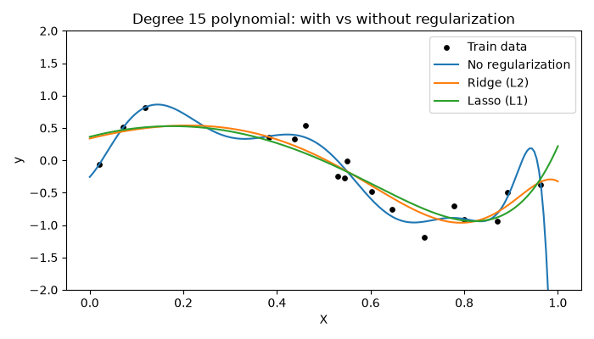
Figure 8.1: Degree 15 polynomial with and without regularization

Observations
- Without regularization, training MSE is tiny (0.0167) but test MSE is much higher (0.5637). That's overfitting.
- Its coefficients add up to about 9264, which is what makes the blue curve swing so wildly, especially on the right.
- Ridge brought test MSE down to 0.0364, about 15 times better, and its coefficient total down to 5.03.
- Lasso had the lowest test MSE, 0.0225. It set 12 of the 16 coefficients to exactly zero and kept just 4.
- Both regularized models have slightly higher training error than the plain one. That's expected, since they've stopped chasing the noise.
- On the graph, the Ridge and Lasso curves are smooth and follow the sine shape, while the plain model bends sharply to touch individual points.

Conclusion
We built a model that overfit on purpose and then fixed it with regularization. Ridge and Lasso both shrank the coefficients, smoothed the curve and cut the test error sharply, and Lasso also dropped most of the unneeded features. Swapping one line of the model was enough to make it work far better on data it hadn't seen.

